The allure of creative freedom and self-expression is undeniable in graphic design, but let's face it, this passion can come with a financial price tag. For aspiring designers, especially those considering a freelance route, navigating the initial stages can be a financial tightrope walk. Imagine wanting to invest in top-of-the-line design software, only to find the price tag exceeding your entire design budget. Finding affordable alternatives or utilizing student discounts becomes crucial for getting your design toolkit started.

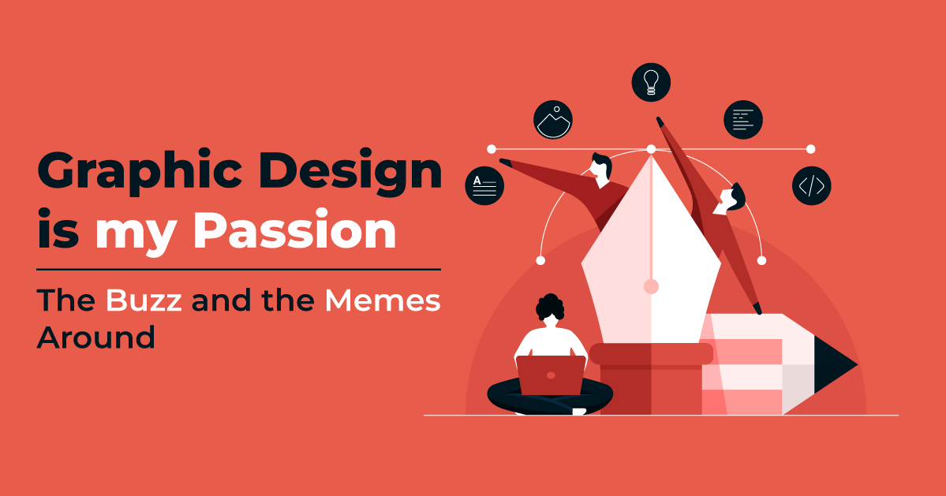

Another financial hurdle involves building a strong portfolio. While some freelance clients might be open to spec work (unpaid design proposals), showcasing your skills often requires creating mock projects. This can mean investing time and resources into personal branding, like building a professional website or attending design conferences. Imagine wanting to network with other designers at a prestigious industry event, but the registration fee throws your budget into disarray. Getting creative with online resources, free portfolio platforms, and attending local design meetups can be budget-friendly alternatives.

However, there's a silver lining. The beauty of graphic design lies in its accessibility. With dedication and resourcefulness, there are ways to circumvent financial limitations. Free online tutorials, open-source design tools, and collaborative design communities offer valuable learning opportunities. Remember, the most impressive portfolio often showcases raw talent and problem-solving skills, not the most expensive software. While financial hurdles exist, the graphic design world welcomes those with a passion for visual storytelling, and with a little creativity, you can bridge the financial gap and embark on your design journey.